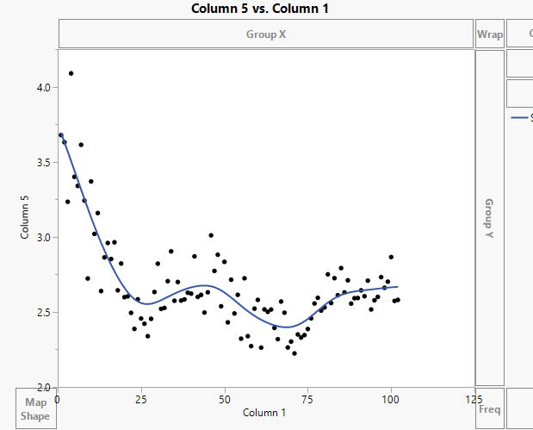

This graph shows the proportion of national vs private brands. It appears that it is trending downwards.

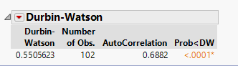

So there is autocorrelation.

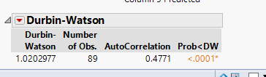

The autocorrelation without outliers is pictured here. We can see even if we choose to remove the weeks where not all 2500 households are present that we would still find a significant amount of autocorrelation.

2.

Market Share:

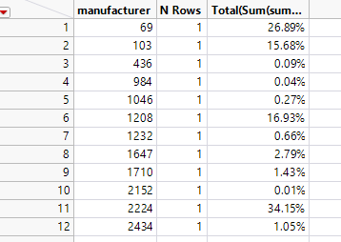

Average Sales Volume:

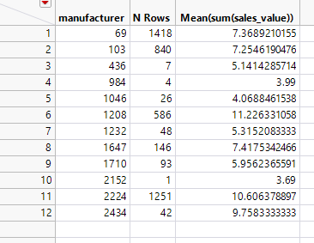

3.

Market Share:

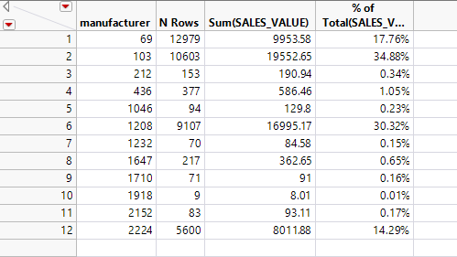

Average Sales:

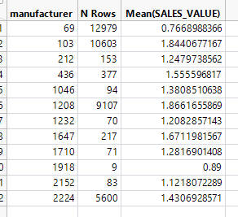

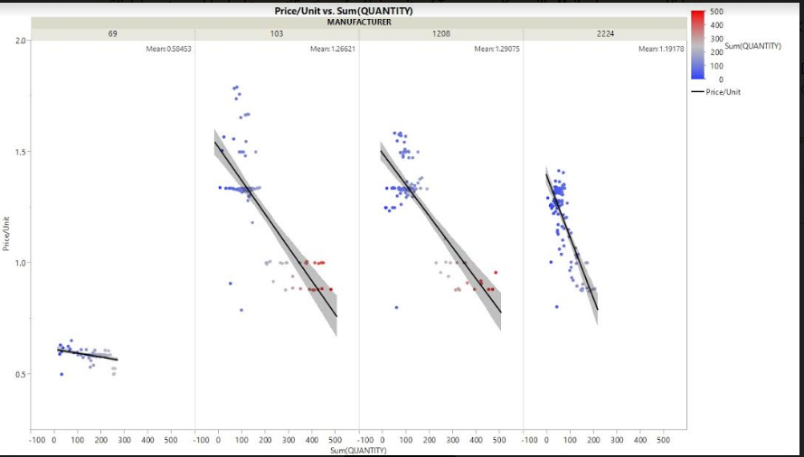

This graph shows price flexibility by comparing the total quantity sold vs the price for each manufacturer. In looking at this we can see about where each manufacturer can charge and still receive good sales.

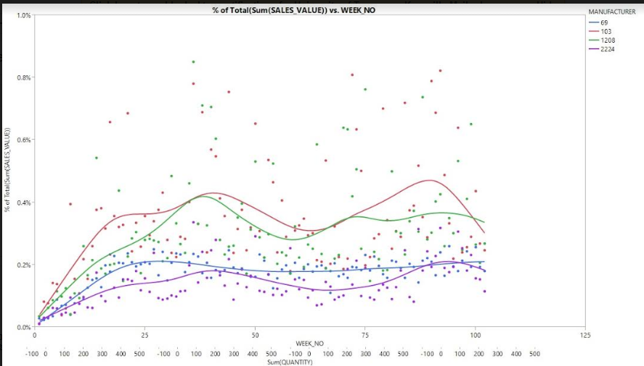

This graph shows the percent of total sales for each week that each manufacturer makes up (market share changes over the weeks)

4.

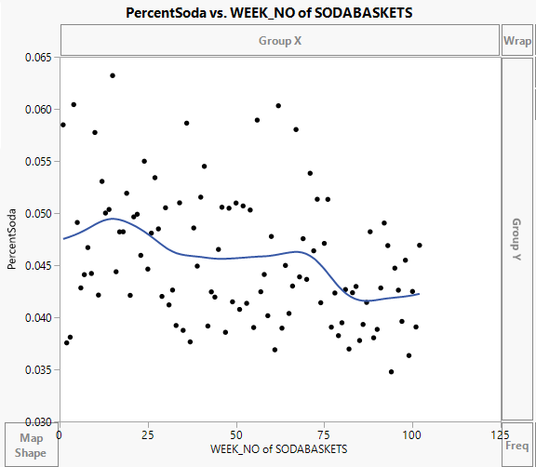

This graph shows the percentage of baskets which contain soda by week. As we can see there is a generally season trend towards higher summer sales but declining sales as well. The percentage is around 5% of baskets containing soda.

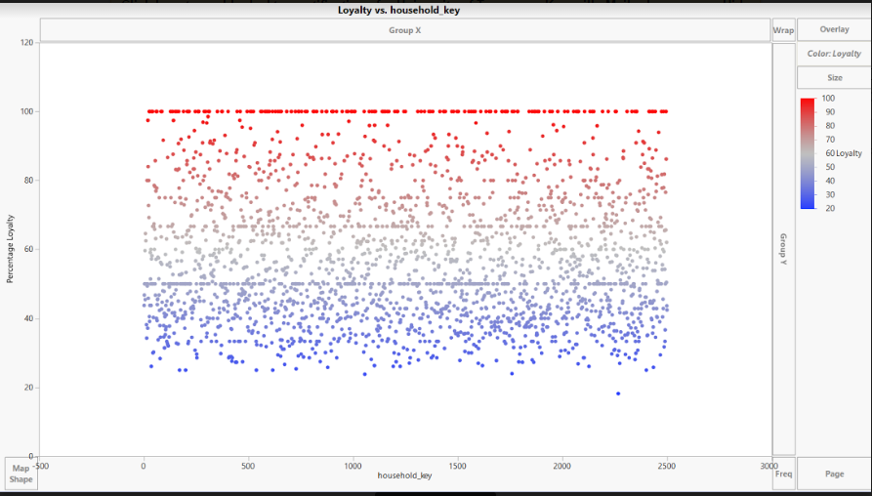

This graph shows brand loyalty. There does not to appear to be much loyalty to manufacturers here.